Scheduled Tasks

This document will show you how to create your own Scheduled Tasks in jBilling by having you follow an example from beginning to end. In our example, you are going to create two scheduled tasks. One is a Simple scheduled task. The other is configured and triggered using a Cron expression. This example or use case may not be useful to you in the future. However, the idea is for you to understand the information in this document, which will enable you to create scheduled tasks and then do something with them.

There are 3 things that you need to do:

1. Create your task and extend from the corresponding class.
2. DB queries.
3. Configure your scheduled task.
4. **Create your task and extend from the corresponding class**

First of all, you need to remember that there are two types of Scheduled Tasks: Simple and Cron. The difference is that a Cron task gives you more flexibility in the configuration. This document is going to show you how to create both types. For each, you need to implement the *IScheduledTask* interface, but instead of doing this, there are already two classes that do this and add extra helper methods.

In order to create a Simple Scheduled Task you need a class that extends from the *AbstractSimpleScheduledTask* class. Implement the necessary methods and override the *execute* one to put your own logic in place.

On the other hand, to create a Cron Scheduled Task you have to extend from *AbstractCronTask* and implement the necessary methods.

For our example I have create the following classes: *TutorialSimpleScheduledTask* and *TutorialCronScheduledTask* as follows:

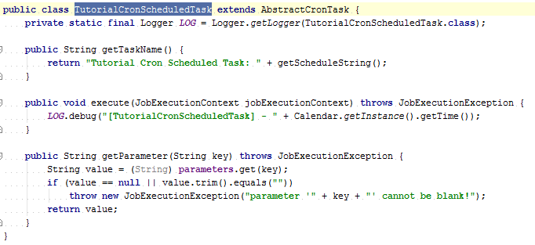

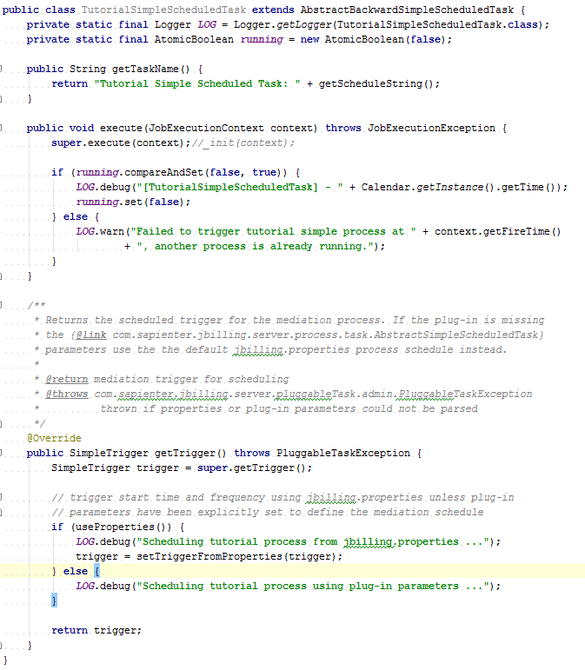

All we do in both implementations is print the current date at the moment of the task’s execution. Reviewing this information will help you to understand how these two types of Scheduled Tasks are created.

1. **DB queries**

Now that you have completed the code implementation, you need to run some DB queries so that jBilling is aware of these new tasks in the system. This includes a new record in the *pluggable_task_type* table to tell jBilling about this new plugin, as well as two records in the *international_description* table to internationalize the description and title of the plugin:

insert into pluggable_task_type (id, category_id, class_name, min_parameters) values (96, 22, 'com.sapienter.jbilling.server.pluggableTask.TutorialSimpleScheduledTask', 2);

insert into international_description (table_id, foreign_id, psudo_column, language_id, content) values (24, 96, 'title', 1, 'Simple Scheduled Task for Tutorial');

insert into international_description (table_id, foreign_id, psudo_column, language_id, content) values (24, 96, 'description', 1, 'Logs every time it runs.');

insert into pluggable_task_type (id, category_id, class_name, min_parameters) values (97, 22, 'com.sapienter.jbilling.server.pluggableTask.TutorialCronScheduledTask', 2);

insert into international_description (table_id, foreign_id, psudo_column, language_id, content) values (24, 97, 'title', 1, 'Cron Scheduled Task for Tutorial');

insert into international_description (table_id, foreign_id, psudo_column, language_id, content) values (24, 97, 'description', 1, 'Logs every time it runs.');

1. **Configure your scheduled task**

The only thing left for you to do is use the UI to configure your new Scheduled task. To configure it in jBilling, you need to go to the Configuration section in the top menu:

Description: C:\Users\jmvidal\Desktop\menu.png

Then click on the Plug-ins link in the left menu to see the list of plug-ins:

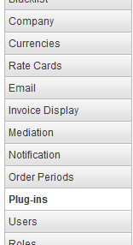

Scroll down and select the *Scheduled Plug-ins* category:

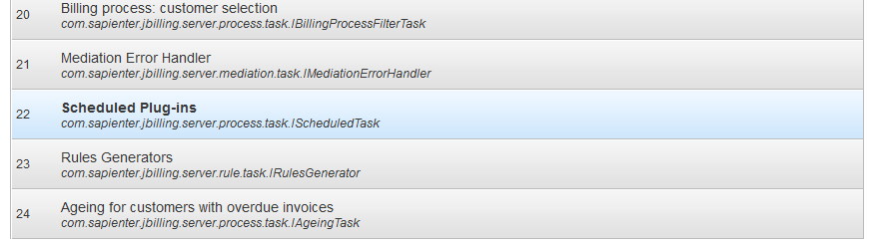

You will see a list of already created/configured Scheduled Tasks. What you have to do is add your recently created task to this list. Click on the Add New button and from the Type list choose your task, configure it and click the Save Plug-in button.

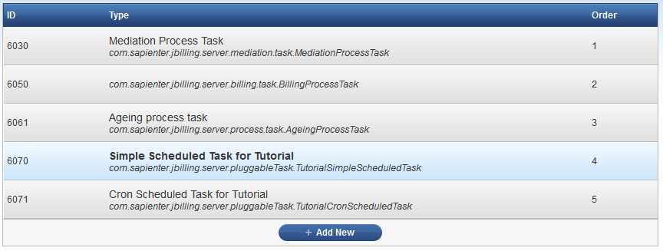

Configuration of the scheduled task varies depending on if it’s a Simple or Cron task.

In a Simple task you have these parameters to configure:

* *start_time:* Start time for the task in *yyyyMMdd-HHmm* format.
* *end_time:* End time for the task in *yyyyMMdd-HHmm* format.
* *repeat:* A number to represent the number of times this task should repeat, default is infinite times.
* *interval:* Hours between two schedules of execution; default is 24 hours.

In a Cron task you only have:

* *cron_exp*: Cron expression of the task’s trigger.

For our example exercise, this is the configuration:

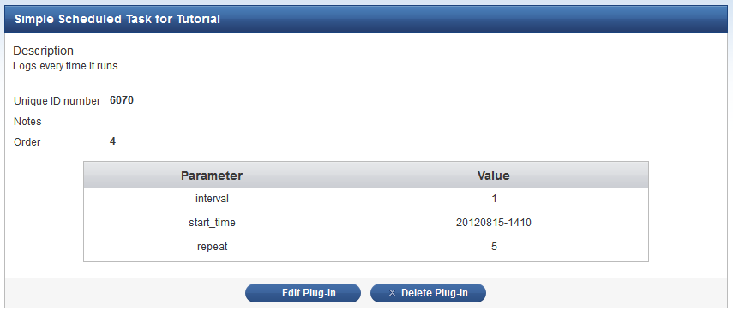

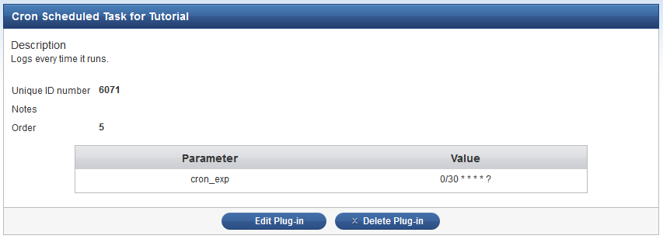

This is all you need to do to create your own Scheduled tasks.

For your reference, in our example, the following are the results you will get in the *jbilling.log* file*:*

2012-08-15 14:57:04,762 DEBUG [com.sapienter.jbilling.server.pluggableTask.TutorialCronScheduledTask] [TutorialCronScheduledTask] - Wed Aug 15 14:57:04 ART 2012

2012-08-15 14:57:31,237 DEBUG [com.sapienter.jbilling.server.pluggableTask.TutorialCronScheduledTask] [TutorialCronScheduledTask] - Wed Aug 15 14:57:31 ART 2012

2012-08-15 14:58:12,896 DEBUG [com.sapienter.jbilling.server.pluggableTask.TutorialCronScheduledTask] [TutorialCronScheduledTask] - Wed Aug 15 14:58:12 ART 2012

2012-08-15 14:58:14,115 DEBUG [com.sapienter.jbilling.server.pluggableTask.TutorialSimpleScheduledTask] [TutorialSimpleScheduledTask] - Wed Aug 15 14:58:14 ART 2012

2012-08-15 14:58:39,531 DEBUG [com.sapienter.jbilling.server.pluggableTask.TutorialCronScheduledTask] [TutorialCronScheduledTask] - Wed Aug 15 14:58:39 ART 2012

2012-08-15 14:59:00,016 DEBUG [com.sapienter.jbilling.server.pluggableTask.TutorialCronScheduledTask] [TutorialCronScheduledTask] - Wed Aug 15 14:59:00 ART 2012

2012-08-15 14:59:30,015 DEBUG [com.sapienter.jbilling.server.pluggableTask.TutorialCronScheduledTask] [TutorialCronScheduledTask] - Wed Aug 15 14:59:30 ART 2012

...

2012-08-15 15:57:00,011 DEBUG [com.sapienter.jbilling.server.pluggableTask.TutorialCronScheduledTask] [TutorialCronScheduledTask] - Wed Aug 15 15:57:00 ART 2012

2012-08-15 15:57:30,018 DEBUG [com.sapienter.jbilling.server.pluggableTask.TutorialCronScheduledTask] [TutorialCronScheduledTask] - Wed Aug 15 15:57:30 ART 2012

2012-08-15 15:58:00,015 DEBUG [com.sapienter.jbilling.server.pluggableTask.TutorialCronScheduledTask] [TutorialCronScheduledTask] - Wed Aug 15 15:58:00 ART 2012

2012-08-15 14:58:14,115 DEBUG [com.sapienter.jbilling.server.pluggableTask.TutorialSimpleScheduledTask] [TutorialSimpleScheduledTask] - Wed Aug 15 15:58:14 ART 2012

2012-08-15 15:58:30,013 DEBUG [com.sapienter.jbilling.server.pluggableTask.TutorialCronScheduledTask] [TutorialCronScheduledTask] - Wed Aug 15 15:58:30 ART 2012

2012-08-15 15:59:00,012 DEBUG [com.sapienter.jbilling.server.pluggableTask.TutorialCronScheduledTask] [TutorialCronScheduledTask] - Wed Aug 15 15:59:00 ART 2012

2012-08-15 15:59:30,011 DEBUG [com.sapienter.jbilling.server.pluggableTask.TutorialCronScheduledTask] [TutorialCronScheduledTask] - Wed Aug 15 15:59:30 ART 2012

Summary

Here is a summary of all the files that were modified/created in order to complete this exercise.

|  |  |  |
| --- | --- | --- |
| File | Updated or Created? | Description |
| *src/java/com/sapienter/jbilling/server/pluggableTask/TutorialSimpleScheduledTask.java* | Created | New Simple Scheduled Task. |
| *src/java/com/sapienter/jbilling/server/pluggableTask/TutorialCronScheduledTask.java* | Created | New Cron Scheduled Task. |

Reference Documentation

Quartz documentation: <http://www.quartz-scheduler.org/documentation/quartz-2.1.x/tutorials/crontrigger>

jBilling extension guide, page 27 - Schedule Driven or Scheduled Plug-ins